# Problem



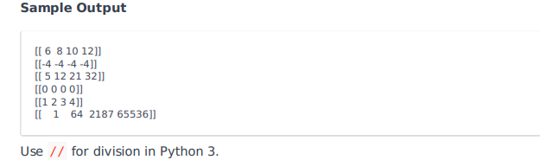

# Josh Solution

import numpy as np

n, m = input().split()

n = int(n)

m = int(m)

a = np.array(input().split(), int)

b = np.array(input().split(), int)

#Add ( + )

print(np.add(a, b))

#Subtract ( - )

print(np.subtract(a, b))

#Multiply ( * )

print(np.multiply(a, b))

#Integer Division ( / )

print(a // b)

#Mod ( % )

print(np.mod(a, b))

#Power ( ** )

print(np.power(a, b))

# Other Solution

import numpy as np

n, m = input().split()

n = int(n)

m = int(m)

a, b = (np.array([input().split() for _ in range(n)], dtype=int) for _ in range(2))

print(a+b, a-b, a*b, a//b, a%b, a**b, sep='\n')

# Note

The 'input().split()' returns a list and the 'for in range(n)' indicates that the list is returned 'n' times. and no it doesnt append it into np array.

Let me explain,

a, b = (np.array([input().split() for _ in range(n)], dtype=int) for _ in range(2))

Here it means that in the first iteration, a list is made into an np.array and given to the variable 'a' In the second iteration, another list is made into an np.array and given to the variable 'b'

The loop is running 2 times since according to problem statement only two such lists will be given as input.